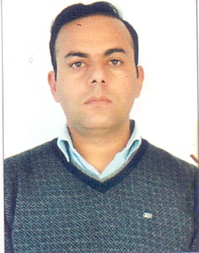
Faculty profile

Name  Email  Contact No. | Dr.Rakesh Sharma  sharmar1975@gmail.com  9419145253
Designation | Professor
Area of Specialization | - Evaluation Research  - Impact Assessment  - Diffusion and Adoption
Publications (in Numbers)  - National  - International | 36  04
Projects Completed | Five
Awards/Honors/ Distinctions | Best KVK Professional Award
Professional experience | 18 yrs
Membership/s of Scientific and Professional Societies | - Life Member of Mobilization Society  - Life Member of Extension Education Society  - Life Member of Ecology  - Life Member of SIDAVES

